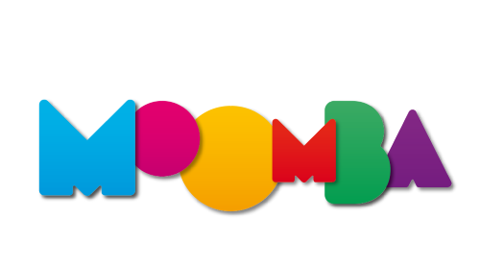
March 2022
Social Story

My adventure at Moomba
This book belongs to

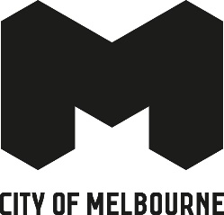

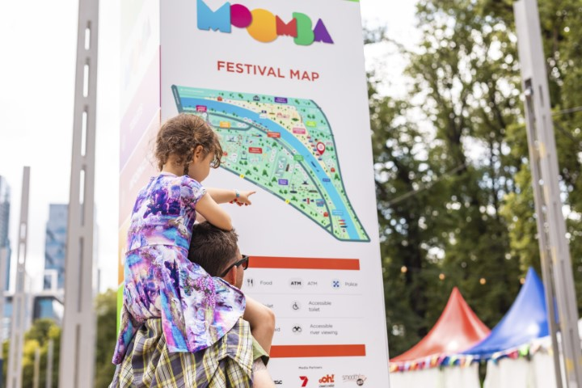
I am going to the city to have fun at Moomba Festival.

There will be lots of people
and noisy places.

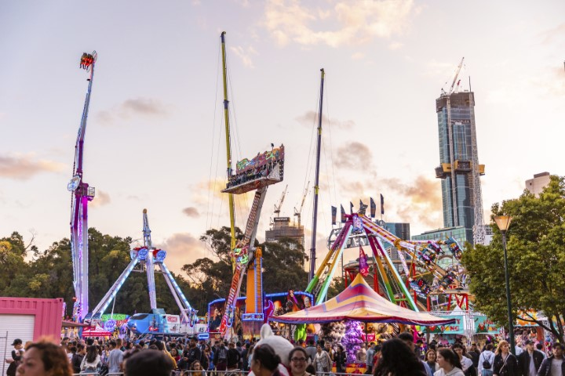

But there will be quieter places too.
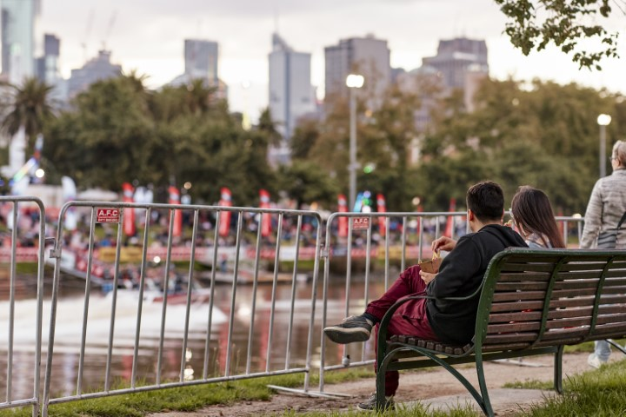
There will be lots of fun of things
to see and do.
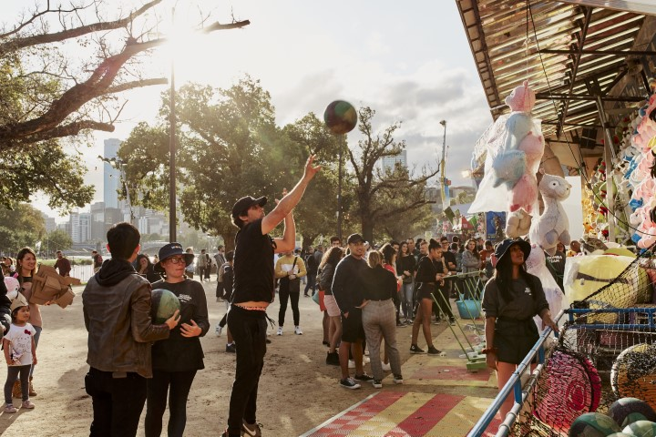
I will see people in costumes.
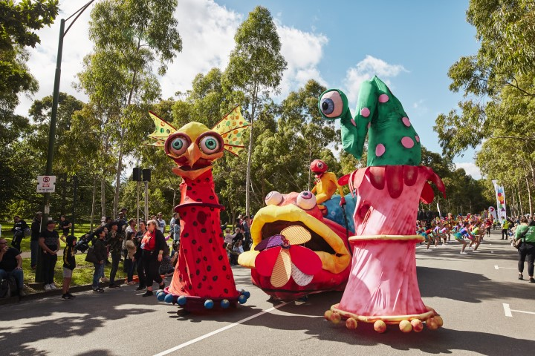

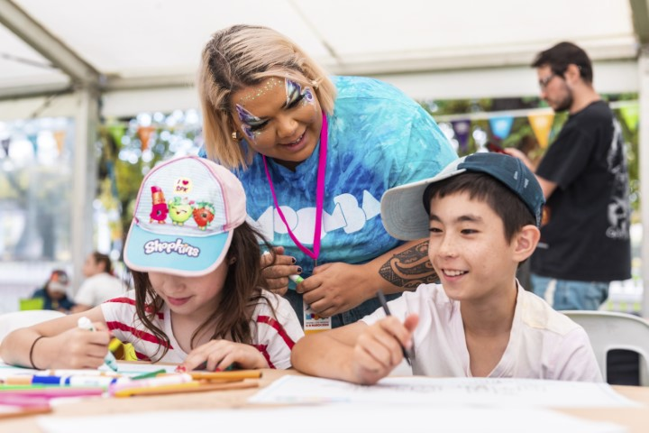
I can do art and craft.
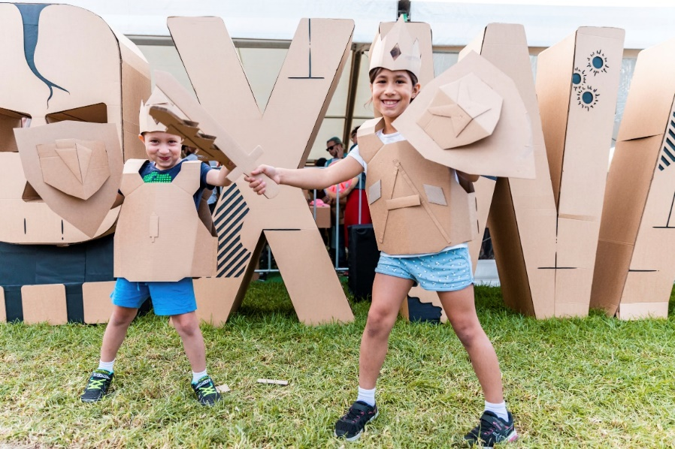

I can build things.
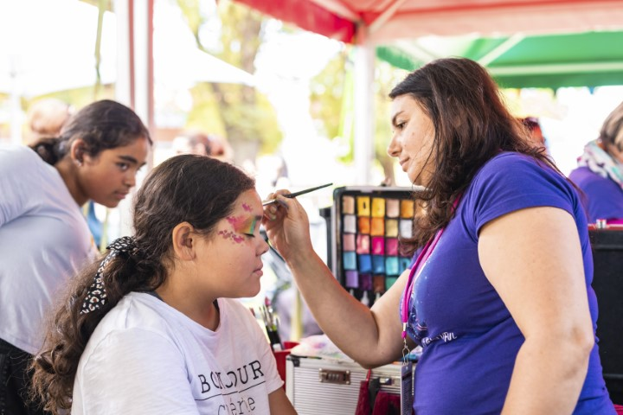
I can have my face painted.
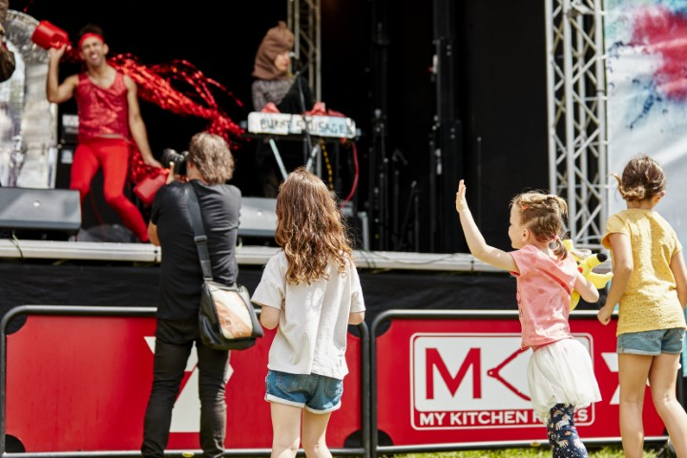

I can sing and dance to music.
There will be yummy food to buy…
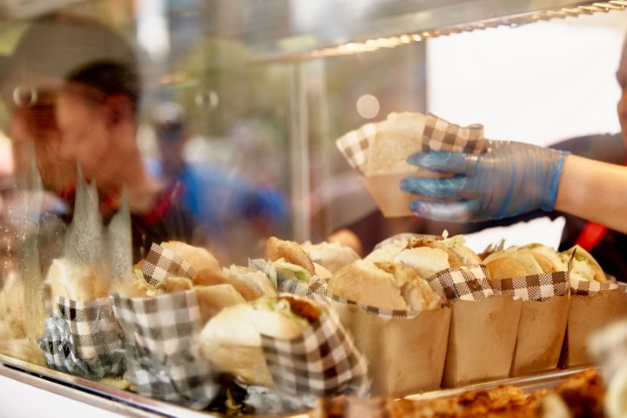

Or I can eat food I bring from home. 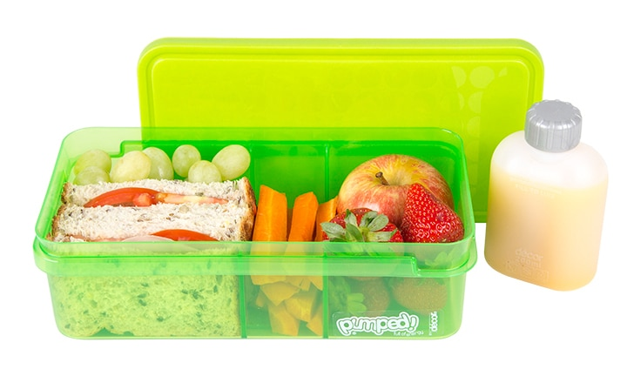
If I need the toilet, I will let my family know and they will help me.
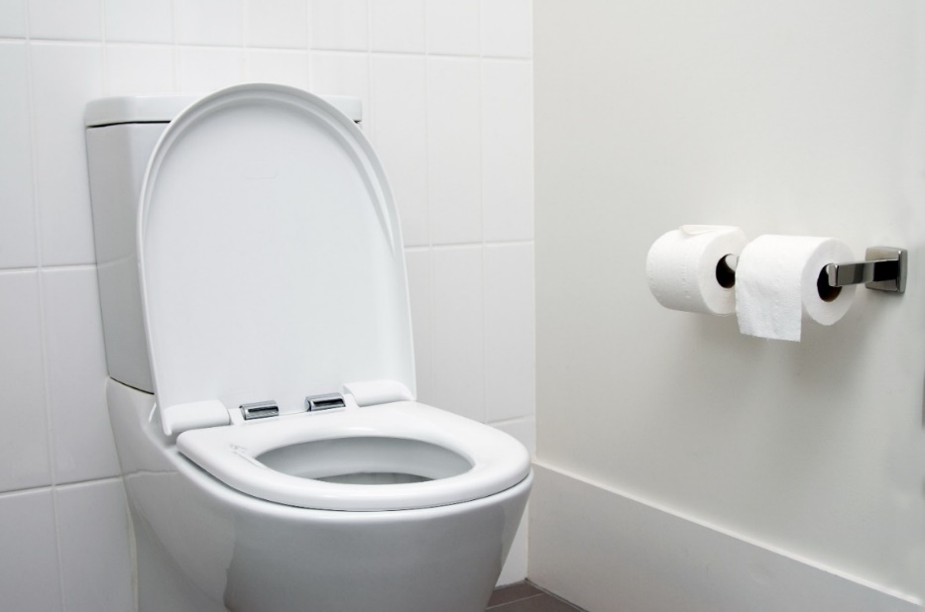

If I get tired or anxious
I can relax in a Quiet Zone in the Traveller’s Aid Marquee.


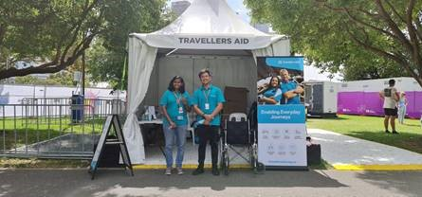
If I need help, I can talk to Event Staff. They are wearing pink Hi-Viz Vests.
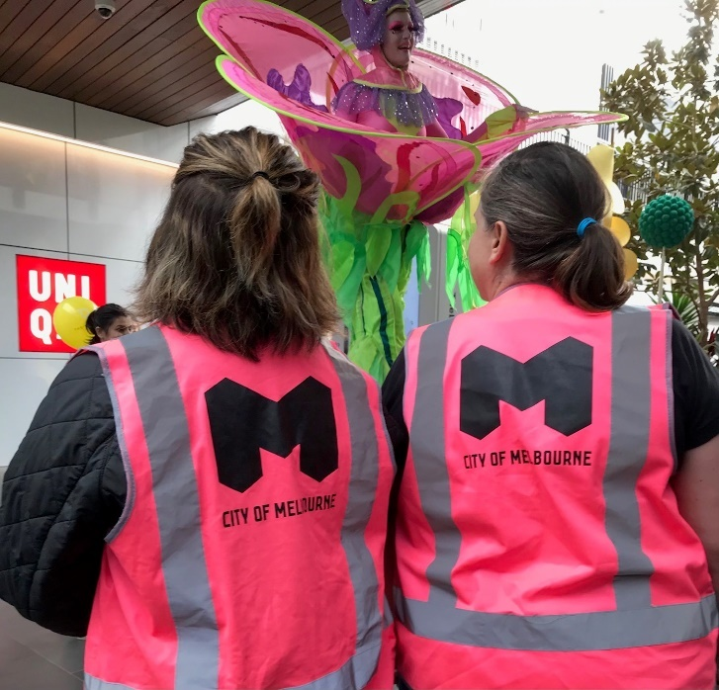
And Sunflower Badges.


